LOGIN SCREEN
Exercise #01
Flutter Developer Bootcamp

Purpose
This Exercise represents a simple login screen UI with text input fields for username and password, login button, and options for social login or signing up.

Problem
The Flutter Exercise creates a login screen UI with username and password text fields, a login button, social media login options, and a signup link. It uses Material Design widgets like Scaffold, Container, TextField, ElevatedButton, IconButton, Row, and TextButton to structure the UI.

How to Solve
1. Checkout the workshop from Git Repo:
git clone -b <user-branch> <repo-URL>
2. Open the root folder inside VS Code
3. To build the app click the run option in the main method { }
4. Create a login screen with:
- Two textfield
- A elevated button
- some icons
- A text and textbutton

You Will Achieve

Your Flutter code creates a simple login screen UI. Here's a breakdown of what it achieves:
- UI Layout: It defines a UI layout for a login screen using Flutter's Scaffold widget, Container, Column, Text, TextField, ElevatedButton, IconButton, and TextButton.
- Styling: It applies styling to various UI elements using properties like backgroundColor, height, width, decoration, borderRadius, style, and colour.
- Interactivity: It includes interactive elements like ElevatedButton, IconButton, and TextButton, though the onPressed callbacks are currently empty (() {}), so they don't perform any actions.
- Social Login: It provides options for social login using IconButton with icons for Facebook, email, and mobile.
- Routing: It includes a "Signup" button which presumably would lead to another screen for user registration, although the onPressed callback is currently empty.
- Accessibility: It uses const keywords wherever possible to optimise performance by avoiding unnecessary rebuilds.
Overall, it's a well-structured Flutter code for a basic login screen UI, but you might want to implement functionality for the buttons and add error handling for text inputs.

Screenshots

Expected Output
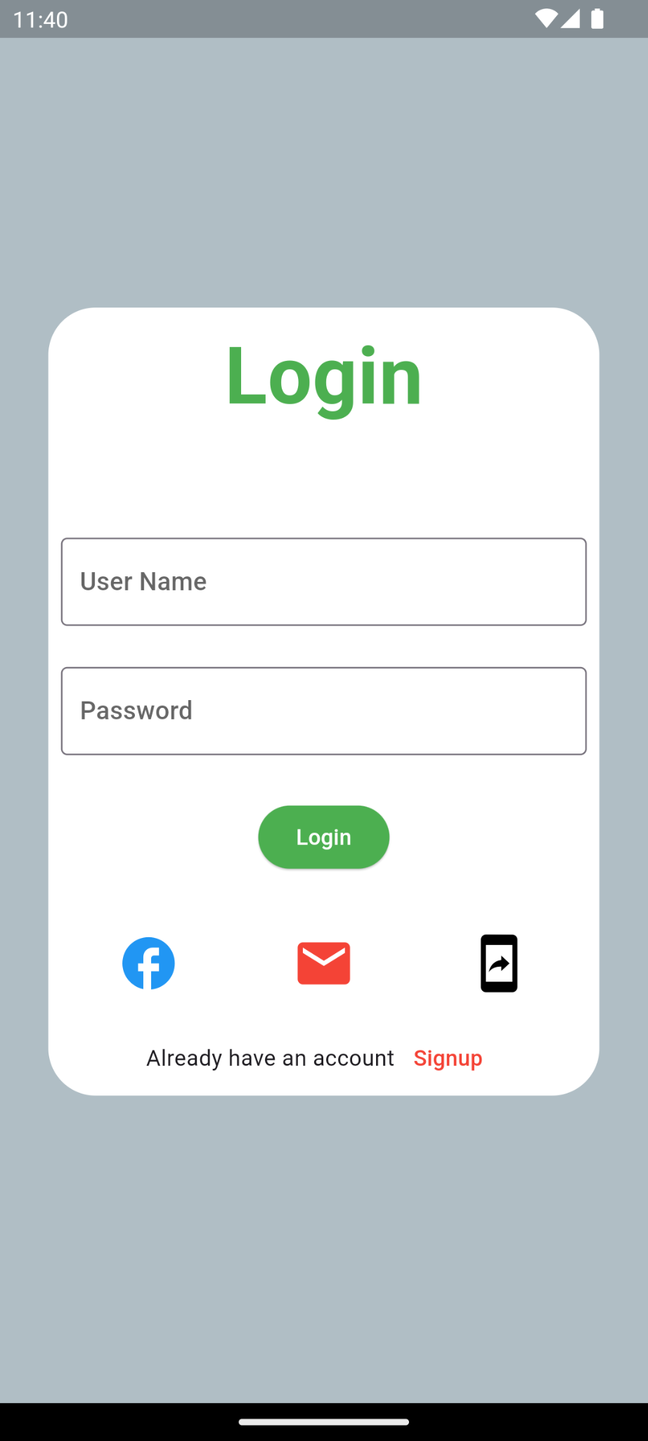

How to submit your Exercise
Push your project back to the same git branch using command:
<command name>

Happy Coding!

